En ocasiones no funciona carga de excel por

* Debug / Properties y asigne plataforma x86
* Driver correcto
* En ocasiones puede funcionar en Debug y no en Release a menos que cambie a x86

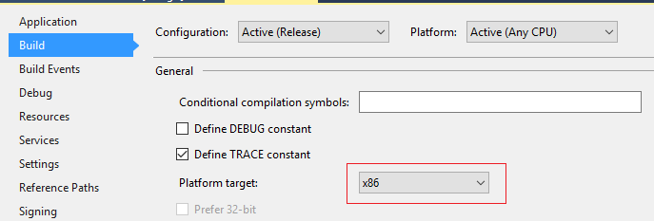

connStringBuilder.Provider = "Microsoft.Jet.OLEDB.4.0";

if (r2.Checked) connStringBuilder.Provider = "Microsoft.ACE.OLEDB.12.0";

connStringBuilder.Add("Extended Properties", "Excel 8.0;HDR=NO;IMEX1");

DbProviderFactory factory =

DbProviderFactories.GetFactory("System.Data.OleDb");

DbDataAdapter da= factory.CreateDataAdapter();

DbCommand selectCommand = factory.CreateCommand();

selectCommand.CommandText = "SELECT \* FROM [Sheet1$]";

DbConnection connection = factory.CreateConnection();

connection.ConnectionString = connStringBuilder.ConnectionString;

selectCommand.Connection = connection;

da.SelectCommand = selectCommand;

System.Data.DataTable dt = new System.Data.DataTable();

da.Fill(dt);